**Traceability Record**

**1. URS : Class diagram**

|  |  |  |  |  |  |  |  |  |  |  |  |  |  |  |  |  |  |  |  |  |  |  |  |  |  |  |  |  |  |  |  |
| --- | --- | --- | --- | --- | --- | --- | --- | --- | --- | --- | --- | --- | --- | --- | --- | --- | --- | --- | --- | --- | --- | --- | --- | --- | --- | --- | --- | --- | --- | --- | --- |
| URS    CD | CD-01 | CD-02 | CD-03 | CD-04 | CD-05 | CD-06 | CD-07 | CD-08 | CD-09 | CD-10 | CD-11 | CD-12 | CD-13 | CD-14 | CD-15 | CD-16 | CD-17 | CD-18 | CD-19 | CD-20 | CD-21 | CD-22 | CD-23 | CD-24 | CD-25 | CD-26 | CD-27 | CD-28 | CD-29 | CD-30 | CD-31 |
| URS-01 | http://www.decodeunicode.org/en/data/glyph/196x196/2714.gif |  |  |  |  | http://www.decodeunicode.org/en/data/glyph/196x196/2714.gif | http://www.decodeunicode.org/en/data/glyph/196x196/2714.gif | http://www.decodeunicode.org/en/data/glyph/196x196/2714.gif | http://www.decodeunicode.org/en/data/glyph/196x196/2714.gif | http://www.decodeunicode.org/en/data/glyph/196x196/2714.gif |  |  |  |  |  |  |  |  |  |  |  |  |  |  |  |  |  |  |  |  | http://www.decodeunicode.org/en/data/glyph/196x196/2714.gif |
| URS-02 |  |  |  |  | http://www.decodeunicode.org/en/data/glyph/196x196/2714.gif |  |  |  |  |  |  |  |  |  |  |  |  |  |  |  |  |  |  |  |  | http://www.decodeunicode.org/en/data/glyph/196x196/2714.gif | http://www.decodeunicode.org/en/data/glyph/196x196/2714.gif | http://www.decodeunicode.org/en/data/glyph/196x196/2714.gif | http://www.decodeunicode.org/en/data/glyph/196x196/2714.gif | http://www.decodeunicode.org/en/data/glyph/196x196/2714.gif | http://www.decodeunicode.org/en/data/glyph/196x196/2714.gif |
| URS-03 | http://www.decodeunicode.org/en/data/glyph/196x196/2714.gif |  |  |  |  | http://www.decodeunicode.org/en/data/glyph/196x196/2714.gif | http://www.decodeunicode.org/en/data/glyph/196x196/2714.gif | http://www.decodeunicode.org/en/data/glyph/196x196/2714.gif | http://www.decodeunicode.org/en/data/glyph/196x196/2714.gif | http://www.decodeunicode.org/en/data/glyph/196x196/2714.gif |  |  |  |  |  |  |  |  |  |  |  |  |  |  |  |  |  |  |  |  | http://www.decodeunicode.org/en/data/glyph/196x196/2714.gif |
| URS-04 | http://www.decodeunicode.org/en/data/glyph/196x196/2714.gif |  |  |  |  | http://www.decodeunicode.org/en/data/glyph/196x196/2714.gif | http://www.decodeunicode.org/en/data/glyph/196x196/2714.gif | http://www.decodeunicode.org/en/data/glyph/196x196/2714.gif | http://www.decodeunicode.org/en/data/glyph/196x196/2714.gif | http://www.decodeunicode.org/en/data/glyph/196x196/2714.gif |  |  |  |  |  |  |  |  |  |  |  |  |  |  |  |  |  |  |  |  | http://www.decodeunicode.org/en/data/glyph/196x196/2714.gif |
| URS-05 |  |  |  | http://www.decodeunicode.org/en/data/glyph/196x196/2714.gif | http://www.decodeunicode.org/en/data/glyph/196x196/2714.gif |  |  |  |  |  |  |  |  |  |  |  |  |  |  |  | http://www.decodeunicode.org/en/data/glyph/196x196/2714.gif | http://www.decodeunicode.org/en/data/glyph/196x196/2714.gif | http://www.decodeunicode.org/en/data/glyph/196x196/2714.gif | http://www.decodeunicode.org/en/data/glyph/196x196/2714.gif | http://www.decodeunicode.org/en/data/glyph/196x196/2714.gif |  |  |  |  |  | http://www.decodeunicode.org/en/data/glyph/196x196/2714.gif |
| URS-06 |  | http://www.decodeunicode.org/en/data/glyph/196x196/2714.gif |  |  | http://www.decodeunicode.org/en/data/glyph/196x196/2714.gif |  |  |  |  |  | http://www.decodeunicode.org/en/data/glyph/196x196/2714.gif | http://www.decodeunicode.org/en/data/glyph/196x196/2714.gif | http://www.decodeunicode.org/en/data/glyph/196x196/2714.gif | http://www.decodeunicode.org/en/data/glyph/196x196/2714.gif | http://www.decodeunicode.org/en/data/glyph/196x196/2714.gif |  |  |  |  |  |  |  |  |  |  |  |  |  |  |  | http://www.decodeunicode.org/en/data/glyph/196x196/2714.gif |
| URS-07 | http://www.decodeunicode.org/en/data/glyph/196x196/2714.gif |  |  | http://www.decodeunicode.org/en/data/glyph/196x196/2714.gif |  |  |  |  |  |  |  |  |  |  |  |  |  |  |  |  | http://www.decodeunicode.org/en/data/glyph/196x196/2714.gif | http://www.decodeunicode.org/en/data/glyph/196x196/2714.gif | http://www.decodeunicode.org/en/data/glyph/196x196/2714.gif | http://www.decodeunicode.org/en/data/glyph/196x196/2714.gif | http://www.decodeunicode.org/en/data/glyph/196x196/2714.gif |  |  |  |  |  | http://www.decodeunicode.org/en/data/glyph/196x196/2714.gif |
| URS-08 | http://www.decodeunicode.org/en/data/glyph/196x196/2714.gif |  |  | http://www.decodeunicode.org/en/data/glyph/196x196/2714.gif |  |  |  |  |  |  |  |  |  |  |  |  |  |  |  |  | http://www.decodeunicode.org/en/data/glyph/196x196/2714.gif | http://www.decodeunicode.org/en/data/glyph/196x196/2714.gif | http://www.decodeunicode.org/en/data/glyph/196x196/2714.gif | http://www.decodeunicode.org/en/data/glyph/196x196/2714.gif | http://www.decodeunicode.org/en/data/glyph/196x196/2714.gif |  |  |  |  |  | http://www.decodeunicode.org/en/data/glyph/196x196/2714.gif |
| URS-09 | http://www.decodeunicode.org/en/data/glyph/196x196/2714.gif |  |  | http://www.decodeunicode.org/en/data/glyph/196x196/2714.gif |  | http://www.decodeunicode.org/en/data/glyph/196x196/2714.gif |  |  |  |  |  |  |  |  |  | http://www.decodeunicode.org/en/data/glyph/196x196/2714.gif | http://www.decodeunicode.org/en/data/glyph/196x196/2714.gif | http://www.decodeunicode.org/en/data/glyph/196x196/2714.gif | http://www.decodeunicode.org/en/data/glyph/196x196/2714.gif | http://www.decodeunicode.org/en/data/glyph/196x196/2714.gif | http://www.decodeunicode.org/en/data/glyph/196x196/2714.gif | http://www.decodeunicode.org/en/data/glyph/196x196/2714.gif | http://www.decodeunicode.org/en/data/glyph/196x196/2714.gif | http://www.decodeunicode.org/en/data/glyph/196x196/2714.gif | http://www.decodeunicode.org/en/data/glyph/196x196/2714.gif |  |  |  |  |  | http://www.decodeunicode.org/en/data/glyph/196x196/2714.gif |
| URS-10 | http://www.decodeunicode.org/en/data/glyph/196x196/2714.gif |  | http://www.decodeunicode.org/en/data/glyph/196x196/2714.gif | http://www.decodeunicode.org/en/data/glyph/196x196/2714.gif |  |  |  |  |  |  |  |  |  |  |  | http://www.decodeunicode.org/en/data/glyph/196x196/2714.gif | http://www.decodeunicode.org/en/data/glyph/196x196/2714.gif | http://www.decodeunicode.org/en/data/glyph/196x196/2714.gif | http://www.decodeunicode.org/en/data/glyph/196x196/2714.gif | http://www.decodeunicode.org/en/data/glyph/196x196/2714.gif |  |  |  |  |  |  |  |  |  |  | http://www.decodeunicode.org/en/data/glyph/196x196/2714.gif |
| URS-11 | http://www.decodeunicode.org/en/data/glyph/196x196/2714.gif |  | http://www.decodeunicode.org/en/data/glyph/196x196/2714.gif |  |  |  |  |  |  |  |  |  |  |  |  | http://www.decodeunicode.org/en/data/glyph/196x196/2714.gif | http://www.decodeunicode.org/en/data/glyph/196x196/2714.gif | http://www.decodeunicode.org/en/data/glyph/196x196/2714.gif | http://www.decodeunicode.org/en/data/glyph/196x196/2714.gif | http://www.decodeunicode.org/en/data/glyph/196x196/2714.gif |  |  |  |  |  |  |  |  |  |  | http://www.decodeunicode.org/en/data/glyph/196x196/2714.gif |
| URS-12 | http://www.decodeunicode.org/en/data/glyph/196x196/2714.gif | http://www.decodeunicode.org/en/data/glyph/196x196/2714.gif | http://www.decodeunicode.org/en/data/glyph/196x196/2714.gif |  |  |  |  |  |  |  | http://www.decodeunicode.org/en/data/glyph/196x196/2714.gif | http://www.decodeunicode.org/en/data/glyph/196x196/2714.gif | http://www.decodeunicode.org/en/data/glyph/196x196/2714.gif | http://www.decodeunicode.org/en/data/glyph/196x196/2714.gif | http://www.decodeunicode.org/en/data/glyph/196x196/2714.gif | http://www.decodeunicode.org/en/data/glyph/196x196/2714.gif | http://www.decodeunicode.org/en/data/glyph/196x196/2714.gif | http://www.decodeunicode.org/en/data/glyph/196x196/2714.gif | http://www.decodeunicode.org/en/data/glyph/196x196/2714.gif | http://www.decodeunicode.org/en/data/glyph/196x196/2714.gif |  |  |  |  |  |  |  |  |  |  | http://www.decodeunicode.org/en/data/glyph/196x196/2714.gif |
| URS-13 | http://www.decodeunicode.org/en/data/glyph/196x196/2714.gif | http://www.decodeunicode.org/en/data/glyph/196x196/2714.gif | http://www.decodeunicode.org/en/data/glyph/196x196/2714.gif |  |  |  |  |  |  |  | http://www.decodeunicode.org/en/data/glyph/196x196/2714.gif | http://www.decodeunicode.org/en/data/glyph/196x196/2714.gif | http://www.decodeunicode.org/en/data/glyph/196x196/2714.gif | http://www.decodeunicode.org/en/data/glyph/196x196/2714.gif | http://www.decodeunicode.org/en/data/glyph/196x196/2714.gif | http://www.decodeunicode.org/en/data/glyph/196x196/2714.gif | http://www.decodeunicode.org/en/data/glyph/196x196/2714.gif | http://www.decodeunicode.org/en/data/glyph/196x196/2714.gif | http://www.decodeunicode.org/en/data/glyph/196x196/2714.gif | http://www.decodeunicode.org/en/data/glyph/196x196/2714.gif |  |  |  |  |  |  |  |  |  |  | http://www.decodeunicode.org/en/data/glyph/196x196/2714.gif |

**2. SRS : URS**

|  |  |  |  |  |  |  |  |  |  |  |  |  |  |
| --- | --- | --- | --- | --- | --- | --- | --- | --- | --- | --- | --- | --- | --- |
| SRS    URS | URS-01 | URS-02 | URS-03 | URS-04 | URS-05 | URS-06 | URS-07 | URS-08 | URS-09 | URS-10 | URS-11 | URS-12 | URS-13 |
| SRS-01 | http://www.decodeunicode.org/en/data/glyph/196x196/2714.gif |  |  |  |  |  |  |  |  |  |  |  |  |
| SRS-02 | http://www.decodeunicode.org/en/data/glyph/196x196/2714.gif |  |  |  |  |  |  |  |  |  |  |  |  |
| SRS-03 | http://www.decodeunicode.org/en/data/glyph/196x196/2714.gif | http://www.decodeunicode.org/en/data/glyph/196x196/2714.gif |  |  |  |  |  |  |  |  |  |  |  |
| SRS-04 | http://www.decodeunicode.org/en/data/glyph/196x196/2714.gif | http://www.decodeunicode.org/en/data/glyph/196x196/2714.gif | http://www.decodeunicode.org/en/data/glyph/196x196/2714.gif | http://www.decodeunicode.org/en/data/glyph/196x196/2714.gif |  |  |  |  |  |  |  |  |  |
| SRS-05 |  | http://www.decodeunicode.org/en/data/glyph/196x196/2714.gif |  |  |  |  |  |  |  |  |  |  |  |
| SRS-06 |  | http://www.decodeunicode.org/en/data/glyph/196x196/2714.gif |  |  |  |  |  |  |  |  |  |  |  |
| SRS-07 |  |  | http://www.decodeunicode.org/en/data/glyph/196x196/2714.gif |  |  |  |  |  |  |  |  |  |  |
| SRS-08 |  |  | http://www.decodeunicode.org/en/data/glyph/196x196/2714.gif |  |  |  |  |  |  |  |  |  |  |
| SRS-09 |  |  | http://www.decodeunicode.org/en/data/glyph/196x196/2714.gif |  |  |  |  |  |  |  |  |  |  |
| SRS-10 |  |  | http://www.decodeunicode.org/en/data/glyph/196x196/2714.gif | http://www.decodeunicode.org/en/data/glyph/196x196/2714.gif |  |  |  |  |  |  |  |  |  |
| SRS-11 |  |  | http://www.decodeunicode.org/en/data/glyph/196x196/2714.gif | http://www.decodeunicode.org/en/data/glyph/196x196/2714.gif |  |  |  |  |  |  |  |  |  |
| SRS-12 |  |  | http://www.decodeunicode.org/en/data/glyph/196x196/2714.gif | http://www.decodeunicode.org/en/data/glyph/196x196/2714.gif |  |  |  |  |  |  |  |  |  |
| SRS-13 |  |  | http://www.decodeunicode.org/en/data/glyph/196x196/2714.gif | http://www.decodeunicode.org/en/data/glyph/196x196/2714.gif |  |  |  |  |  |  |  |  |  |
| SRS-14 |  |  | http://www.decodeunicode.org/en/data/glyph/196x196/2714.gif | http://www.decodeunicode.org/en/data/glyph/196x196/2714.gif |  |  |  |  |  |  |  |  |  |
| SRS-15 |  |  | http://www.decodeunicode.org/en/data/glyph/196x196/2714.gif | http://www.decodeunicode.org/en/data/glyph/196x196/2714.gif |  | http://www.decodeunicode.org/en/data/glyph/196x196/2714.gif |  |  |  |  |  |  |  |
| SRS-16 |  |  | http://www.decodeunicode.org/en/data/glyph/196x196/2714.gif | http://www.decodeunicode.org/en/data/glyph/196x196/2714.gif |  |  |  |  |  |  |  |  |  |
| SRS-17 |  |  | http://www.decodeunicode.org/en/data/glyph/196x196/2714.gif | http://www.decodeunicode.org/en/data/glyph/196x196/2714.gif |  |  |  |  |  |  |  |  |  |
| SRS-18 |  |  | http://www.decodeunicode.org/en/data/glyph/196x196/2714.gif | http://www.decodeunicode.org/en/data/glyph/196x196/2714.gif |  | http://www.decodeunicode.org/en/data/glyph/196x196/2714.gif |  |  |  |  |  |  |  |
| SRS-19 |  |  |  | http://www.decodeunicode.org/en/data/glyph/196x196/2714.gif |  |  |  |  |  |  |  |  |  |
| SRS-20 |  |  |  |  | http://www.decodeunicode.org/en/data/glyph/196x196/2714.gif |  |  |  |  |  |  |  |  |
| SRS-21 |  |  |  |  | http://www.decodeunicode.org/en/data/glyph/196x196/2714.gif |  |  |  |  |  |  |  |  |
| SRS-22 |  |  |  |  |  | http://www.decodeunicode.org/en/data/glyph/196x196/2714.gif |  |  |  |  |  |  |  |
| SRS-23 |  |  |  |  |  | http://www.decodeunicode.org/en/data/glyph/196x196/2714.gif |  |  |  |  |  |  |  |
| SRS-24 |  |  |  |  |  |  | http://www.decodeunicode.org/en/data/glyph/196x196/2714.gif |  |  |  |  |  |  |
| SRS-25 |  |  |  |  |  |  | http://www.decodeunicode.org/en/data/glyph/196x196/2714.gif |  |  |  |  |  |  |
| SRS-26 |  |  |  |  |  |  |  | http://www.decodeunicode.org/en/data/glyph/196x196/2714.gif |  |  |  |  |  |
| SRS-27 |  |  |  |  |  |  |  | http://www.decodeunicode.org/en/data/glyph/196x196/2714.gif |  |  |  |  |  |
| SRS-28 |  |  |  |  |  |  |  |  | http://www.decodeunicode.org/en/data/glyph/196x196/2714.gif |  |  |  |  |
| SRS-29 |  |  |  |  |  |  |  |  | http://www.decodeunicode.org/en/data/glyph/196x196/2714.gif |  |  |  |  |
| SRS-30 |  |  |  |  |  |  |  |  | http://www.decodeunicode.org/en/data/glyph/196x196/2714.gif |  |  |  |  |
| SRS-31 |  |  |  |  |  |  |  |  | http://www.decodeunicode.org/en/data/glyph/196x196/2714.gif |  |  |  |  |
| SRS-32 |  |  |  |  |  |  |  |  |  | http://www.decodeunicode.org/en/data/glyph/196x196/2714.gif |  |  |  |
| SRS-33 |  |  |  |  |  |  |  |  |  | http://www.decodeunicode.org/en/data/glyph/196x196/2714.gif |  |  |  |
| SRS-34 |  |  |  |  |  |  |  |  |  | http://www.decodeunicode.org/en/data/glyph/196x196/2714.gif |  |  |  |
| SRS-35 |  |  |  |  |  |  |  |  |  |  | http://www.decodeunicode.org/en/data/glyph/196x196/2714.gif |  |  |
| SRS-36 |  |  |  |  |  |  |  |  |  |  | http://www.decodeunicode.org/en/data/glyph/196x196/2714.gif |  |  |
| SRS-37 |  |  |  |  |  |  |  |  |  |  | http://www.decodeunicode.org/en/data/glyph/196x196/2714.gif |  |  |
| SRS-38 |  |  |  |  |  |  |  |  |  |  | http://www.decodeunicode.org/en/data/glyph/196x196/2714.gif |  |  |
| SRS-39 |  |  |  |  |  |  |  |  |  |  |  | http://www.decodeunicode.org/en/data/glyph/196x196/2714.gif |  |
| SRS-40 |  |  |  |  |  |  |  |  |  |  |  | http://www.decodeunicode.org/en/data/glyph/196x196/2714.gif |  |
| SRS-41 |  |  |  |  |  |  |  |  |  |  |  | http://www.decodeunicode.org/en/data/glyph/196x196/2714.gif |  |
| SRS-42 |  |  |  |  |  |  |  |  |  |  |  | http://www.decodeunicode.org/en/data/glyph/196x196/2714.gif |  |
| SRS-43 |  |  |  |  |  |  |  |  |  |  |  | http://www.decodeunicode.org/en/data/glyph/196x196/2714.gif |  |
| SRS-44 |  |  |  |  |  |  |  |  |  |  |  | http://www.decodeunicode.org/en/data/glyph/196x196/2714.gif |  |
| SRS-45 |  |  |  |  |  |  |  |  |  |  |  |  | http://www.decodeunicode.org/en/data/glyph/196x196/2714.gif |
| SRS-46 |  |  |  |  |  |  |  |  |  |  |  |  | http://www.decodeunicode.org/en/data/glyph/196x196/2714.gif |

**3. URS : Use case diagram**

|  |  |  |  |  |  |  |  |  |  |  |  |  |  |
| --- | --- | --- | --- | --- | --- | --- | --- | --- | --- | --- | --- | --- | --- |
| URS    Use case | UC-01 | UC-02 | UC-03 | UC-04 | UC-05 | UC-06 | UC-07 | UC-08 | UC-09 | UC-10 | UC-11 | UC-12 | UC-13 |
| URS-01 | http://www.decodeunicode.org/en/data/glyph/196x196/2714.gif |  |  |  |  |  |  |  |  |  |  |  |  |
| URS-02 |  | http://www.decodeunicode.org/en/data/glyph/196x196/2714.gif |  |  |  |  |  |  |  |  |  |  |  |
| URS-03 |  |  | http://www.decodeunicode.org/en/data/glyph/196x196/2714.gif |  |  |  |  |  |  |  |  |  |  |
| URS-04 |  |  |  | http://www.decodeunicode.org/en/data/glyph/196x196/2714.gif |  |  |  |  |  |  |  |  |  |
| URS-05 |  |  |  |  | http://www.decodeunicode.org/en/data/glyph/196x196/2714.gif |  |  |  |  |  |  |  |  |
| URS-06 |  |  |  |  |  | http://www.decodeunicode.org/en/data/glyph/196x196/2714.gif |  |  |  |  |  |  |  |
| URS-07 |  |  |  |  |  |  | http://www.decodeunicode.org/en/data/glyph/196x196/2714.gif |  |  |  |  |  |  |
| URS-08 |  |  |  |  |  |  |  | http://www.decodeunicode.org/en/data/glyph/196x196/2714.gif |  |  |  |  |  |
| URS-09 |  |  |  |  |  |  |  |  | http://www.decodeunicode.org/en/data/glyph/196x196/2714.gif |  |  |  |  |
| URS-10 |  |  |  |  |  |  |  |  |  | http://www.decodeunicode.org/en/data/glyph/196x196/2714.gif |  |  |  |
| URS-11 |  |  |  |  |  |  |  |  |  |  | http://www.decodeunicode.org/en/data/glyph/196x196/2714.gif |  |  |
| URS-12 |  |  |  |  |  |  |  |  |  |  |  | http://www.decodeunicode.org/en/data/glyph/196x196/2714.gif |  |
| URS-13 |  |  |  |  |  |  |  |  |  |  |  |  | http://www.decodeunicode.org/en/data/glyph/196x196/2714.gif |

**4. URS : Sequence diagram**

|  |  |  |  |  |  |  |  |  |  |  |  |  |  |
| --- | --- | --- | --- | --- | --- | --- | --- | --- | --- | --- | --- | --- | --- |
| URS    SQD | SD-01 | SD-02 | SD-03 | SD-04 | SD-05 | SD-06 | SD-07 | SD-08 | SD-09 | SD-10 | SD-11 | SD-12 | SD-13 |
| URS-01 | http://www.decodeunicode.org/en/data/glyph/196x196/2714.gif |  |  |  |  |  |  |  |  |  |  |  |  |
| URS-02 |  | http://www.decodeunicode.org/en/data/glyph/196x196/2714.gif |  |  |  |  |  |  |  |  |  |  |  |
| URS-03 |  |  | http://www.decodeunicode.org/en/data/glyph/196x196/2714.gif |  |  |  |  |  |  |  |  |  |  |
| URS-04 |  |  |  |  |  |  |  |  |  |  |  |  | http://www.decodeunicode.org/en/data/glyph/196x196/2714.gif |
| URS-05 |  |  |  |  |  |  |  | http://www.decodeunicode.org/en/data/glyph/196x196/2714.gif |  | http://www.decodeunicode.org/en/data/glyph/196x196/2714.gif | http://www.decodeunicode.org/en/data/glyph/196x196/2714.gif | http://www.decodeunicode.org/en/data/glyph/196x196/2714.gif |  |
| URS-06 |  |  |  |  |  |  |  |  | http://www.decodeunicode.org/en/data/glyph/196x196/2714.gif |  |  |  |  |
| URS-07 |  |  |  |  |  | http://www.decodeunicode.org/en/data/glyph/196x196/2714.gif |  |  |  |  |  |  |  |
| URS-08 |  |  |  | http://www.decodeunicode.org/en/data/glyph/196x196/2714.gif |  |  |  |  |  |  |  |  |  |
| URS-09 |  |  |  | http://www.decodeunicode.org/en/data/glyph/196x196/2714.gif |  | http://www.decodeunicode.org/en/data/glyph/196x196/2714.gif |  |  |  |  |  |  |  |
| URS-10 |  |  |  |  |  | http://www.decodeunicode.org/en/data/glyph/196x196/2714.gif |  |  |  |  |  |  |  |
| URS-11 |  |  |  |  | http://www.decodeunicode.org/en/data/glyph/196x196/2714.gif | http://www.decodeunicode.org/en/data/glyph/196x196/2714.gif |  |  |  |  |  |  |  |
| URS-12 |  |  |  |  | http://www.decodeunicode.org/en/data/glyph/196x196/2714.gif |  |  |  |  |  |  |  |  |
| URS-13 |  |  |  |  |  |  | http://www.decodeunicode.org/en/data/glyph/196x196/2714.gif |  |  |  |  |  |  |

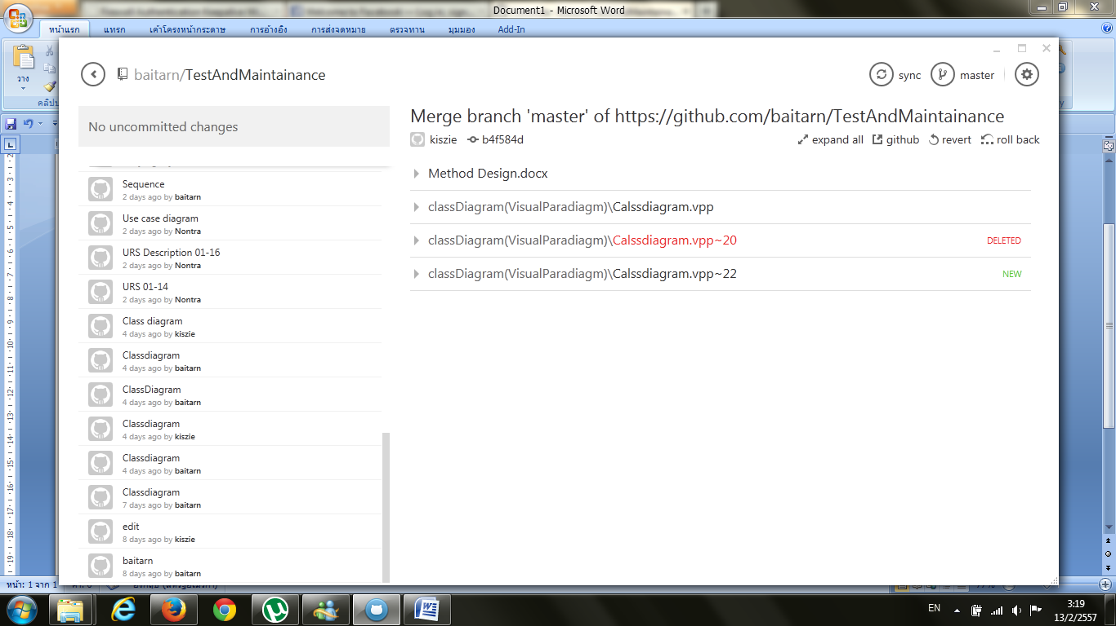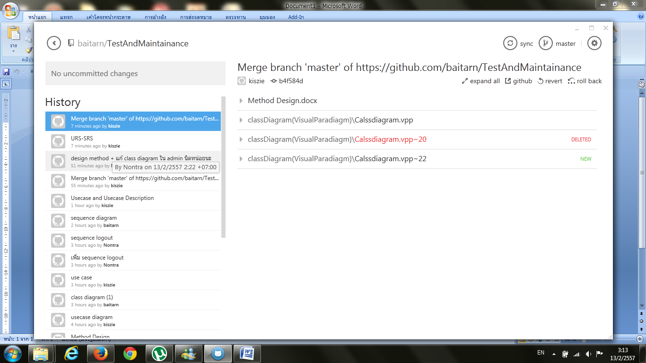**Version Control**

